

**Assignment**

Experiment No: 04

Experiment Name: Sequence Diagram for ATM

Course Title: System Analysis and Design

Course Code: CSE 326

Submitted To:

Supta Richard Philip

Senior Lecturer

Department of CSE

City University Dhaka

Submitted By:

Name:Hafijur Rahman

ID: 171442648

Batch: 44th

Program:CSE(Eve)

Submission Date: 28/06/19

**About Sequence Diagram**

A sequence diagram (sometimes called event diagrams or event scenarios) shows object interactions arranged in time sequence. Sequence diagrams are typically associated with realization of a use case scenario. A sequence diagram depicts the objects participated in a use case scenario and the sequence of messages exchanged between the objects (also called the flow of event in textual form) needed to carry out the functionality of the scenario.

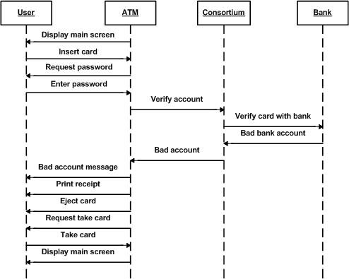Description:

A sequence diagram shows objects and the messages that are passed between these objects for the particular collaboration. This is a simple sequence diagram example for ATM. It shows the interaction from inserting card to verifying account and rejecting card.

To edit this sequence diagram template, simply click on Use this Template. Afterwards, you'll be able to add and remove actors and lifelines to your liking.